MITEX 2022

8. – 11. November 2022
Expocentre, Moscow

TECHNICAL MANUAL
for Exhibitors

INTERNATIONAL TRADE FAIR
Expocentre, Pavilion 1, “Forum”

Organized by:

MEET YOUR BUSINESS
Contact Information

Euroexpo Exhibitions & Congress Development, Vienna
Wagenseilgasse 3, Euro Plaza, Bldg.5i, 3rd Floor
1120 Vienna, Austria
Tel.: + 43 1 230 85 35
Fax: + 43 1 230 85 35 - 50/-51
www.euroexpo-vienna.com

For MITEX 2019 please contact:

Mr. Michael Haeussler
Project Director

Direct line: + 43 1 230 85 35 – 34
Fax: + 43 1 230 85 35 -50/-51
Mobile: + 43 660 3020107
E-mail: m.haeussler@euroexpo-vienna.com

For technical questions, standard and individual stand constructions please contact:
Mr. Kirill Gavrilin
Technical Manager
Stand Construction

Direct line: + 43 1 230 85 35 – 39
Fax: + 43 1 230 85 35 -50/-51
Mobile: + 43 660 3020108
E-mail: k.gavrilin@euroexpo-vienna.com
EXPOCENTRE
14, Krasnopresnenskaya nab., Moscow, Russia, 123100
Tel.: + 7 (499) 795-37-99, 795-39-46
Fax: + 7 (495) 605-72-10
E-mail: centr@expocentr.ru
http://www.expocentr.ru/en/

Expocentre’s general contractor is ExpoConsta, ZAO
1st Krasnogvardeisky Proezd, 1
Moscow, Russia, 123100
Tel.: + 7 (499) 795 39 03
Fax: + 7 (499) 795 28 44
E-mail: sales@expoconsta.ru
Communications, Audio and Video Services, Internet
Tel.: + 7 (499) 795-37-93, + 7 (499) 256-74-44
Fax: + 7 (499) 795-27-23
E-mail: telcom@expocentr.ru

Expowestrans, ZAO
Expocentre’s General Forwarding Agent
Freight and forwarding services, customs brokerage
Krasnopresnenskaya Nab., 14, Str. 2
Moscow, Russia, 123100
Tel.: + 7 (495) 605 6650
Fax: + 7 (495) 605 3431
E-mail: ewt@ewt.ru

Exhibition Timetable

Exhibition Assembly / Exhibition Operating Schedule / Dismantling of Exhibition

Dates | Time | Activity | Location
November 7, 2022 | 8:00 – 20:00  9:00 – 19:00 | Stand set-up  Exhibitors check-in | Pavilion 1  Pavilion “Forum”
November 8, 2022 | 10:00 – 18:00  12:00 | Official opening hours  Opening ceremony
November 9 – 10, 2022 | 10:00 – 18:00 | Official opening hours
November 11, 2022 | 10:00 – 16:00  16:00  16:00 – 20:00 | Official opening hours  Closing of the exhibition  Dismantling

Booth Construction

Equipped Space / Standard Booth:

Standard package includes:

- Carpet flooring
- Wall panels (white color and 2.5 meters high)
- Electrical equipment, incl. 10 kW power supply
- Furniture package

Subject to possible changes in the standard package:

- Exhibitors may alter colour of the walls, fascia boards, information counters and podiums by ordering of additional graphics.
- Exhibitors may change the colour of the carpet.
- Exhibitors may augment the standard stand height – 2,5 meters, by means of extra assembly units.

If you require additional furniture or services for your stand, please refer to the order forms for additional equipment and services.

ATTENTION!!!

No money refund will be made in case of cancellation of any equipment which is included in the standard package. Free replacement of equipment to another is not possible.

Exhibits’ requirements: Exhibitors who book equipped space and wish to install a mobile stand or to deliver stand construction elements (banners, carpet, decoration and construction elements) must submit a request to ZAO Expoconsta and Fire Department No.160. Certifications of conformity to fire standards are needed when using banners or other hanging materials.

For more information please contact:
EXPOCONSTA Company
Technical Control Department
Tel.: +7 (499) 795-39-03
Fax: +7 (499) 795-28-44
E-mail: sales@expoconsta.ru
Contact details: https://www.expoconsta.com/en/technical-control/main-activities-and-contacts/

Fire Department No.160: +7 (499) 259 13 12

Advertising Activities: When planning the advertising activities and working exhibits demonstration at your stand, please note that the sound pressure level shall not exceed 75 dB on the boundaries of the indoor stand and within 5 m of the borders of the outdoor stand. This restriction is imposed in the visitors and other exhibitor’s interests. The sound pressure level is controlled by metering equipment. The violation of this restriction is subject to penalty of 300 000 RUR (VAT excluded), and disconnection of the stand from electrical supply. The violation is to be fixed by the act, and the penalty is imposed immediately.

Banners and draping materials: All banners, Rool-Up’s and draping materials used during the exhibition must have the Certificate of Conformity to the Requirements of Fire Safety of the Russian Federation. The function of the given certificate is to prove conformity of the production to the approved rules of safety in Russia.

All banners and draping materials produced abroad are usually NOT in conformity with the rules of fire safety used in the Russian Federation and therefore, it is almost impossible to obtain such certificates from responsible official authorities in Russia. Banners and other draping materials that are lacking Fire Safety Certificate of the Russian Federation should be removed from the exhibition. Therefore, we highly recommend you to order all banners and draping material form Euroexpo.

Wall panels and other additional construction components must remain after the exhibition in non-damaged form and be cleaned of any remainders of adhesive tape, posters, etc. Drilling of holes, the attaching of advertising and other materials with pins, buttons, hard-to-remove adhesive tape, etc., is impermissible. Otherwise, the cost of damaged or non-cleaned components of the booth’s construction and additional equipment will be imposed on the participating company. A statement about component damage will be drawn up.

ATTENTION!!!

Penalty for damaged or non-cleaned components of the booth’s construction and additional equipment:

200,- EUR - for each wall panel
150,- EUR - for each panel of information desk, show-case,
cupboard, fascia board panel, etc.

Security: During assembly/dismantling as well as during the exhibition the pavilion is locked at 8:00 p.m. and unlocked at 8:00 a.m. and security service is given during this time. Unfortunately, thieves have been operating recently on the grounds of exhibition centers. To ensure security of exhibits, we suggest having at least one employee of your firm attending the booth during assembly and the exhibition. We also earnestly recommend that you NOT leave during the exhibition without the supervision of valuable things, documents and money.
If needed, you can order a private guard by Expocentre, Service and Protocol Department
Tel.: +7 (499) 795-2664,-2637,-3992,-2563,-3986
E-mail: usluga@expocentr.ru

Stand cleaning: During assembly/dismantling of the exhibition, every day there will be cleaning of the aisles (of minor construction waste). Every morning, before the exhibition opens for visitors, cleaning of the aisles between the booths will be performed. The waste left by you the evening before, in front of the booth, must be packed in a plastic bag.
Cleaning of the booths is not included in the booth’s cost. If you need to order cleaning, you can fill out order form 3.

We would like to remind you that all stand set-up works must be completed and the packaging material must be taken out of the exhibition pavilion on 08.11.2022 at 09:30 a.m.

If the Exhibitor fails to observe these rules and to move-out the exhibits in time, the Expocentre reserves the right to dispatch the remaining exhibits to the warehouse of ZAO “ExpoWesTrans” (1st Krasnogvardeisky proezd 14, tel.: +7 (495) 605-03-27, 605-74-21, fax: +7 (495) 605-79-35). The exhibits will be transferred to the warehouse and stored there at the Exhibitor’s expense. Transfer and warehousing of the exhibits will be charged according to ZAO “ExpoWesTrans” rates.

The Directorate asks you to pay attention to some rules of participation in exhibitions, the implementation of which will allow us to avoid conflict situations.

▪ Retail sale of exhibits and samples from the stand during the exhibition is prohibited. Those guilty of violating this rule may be held administratively liable and will be excluded from the list of potential participants in all exhibitions held on the territory of the Expocentre Central Exhibition Complex.
▪ Loud announcements, music and presentations (above 75 dB), interfering with the work of nearby stands, are unacceptable. If this requirement is not met, the management has the right to prohibit further holding of the event and impose a fine.
▪ To ensure the safety of small exhibits that are not placed in closed premises, we suggest that you ensure the presence of an employee of your company at the stand during installation, after the delivery of exhibits and during the exhibition (09 - 12 November 2021) from 08:00. until 10:00 a.m. and from 18:00 p.m. until 20:00, i.e. before the opening and after the closing of the exhibition for visitors.

The organizers of the exhibition and the Expocentre Fairgrounds are not responsible for the safety of your exhibits and personal belongings.

Unequipped Space

Construction of an Exclusive Stand via Euroexpo

Euroexpo has an enormous experience in exhibition stands design and construction. Our individual approach to each project, combined with the many years of work experience ensure that our stand design has prime quality, affordable solution and meets all customer`s expectation.

Our company ensures compliance with all technical requirements, including documentation, admission and all necessary authorizations of exhibition center’s authorities. We help you to deal with transportation, costumer clearance procedures, fire department regulation etc.

To order an individual stand, please contact:
Euroexpo Vienna:
Mr. Kirill Gavrilin
Tel.: +43 1 230 85 35 39
Fax: +43 1 230 85 35 -50/-51
Email: k.gavrilin@euroexpo-vienna.com

Construction of an Exclusive Stand via third-party constructor

Carrying out of assembling and disassembling works as well as decorating works by Exhibitor’s own recourses or third-party contractors is allowed only in case of constructing of an exclusive exhibition stands.

Exclusive stand is defined as a stand which meets at least one of the following conditions:

- Stands, constructed by applying the following materials: wood, resin-bonded chipboard, fiberboard, textile etc.
- Stands, constructed by means of assembly units, representing individual designer approach, requiring non-standard type and size assembly units.
- Two-story stands.
Panel pasting, logo imprint, wall height augmentation, pendant/suspended units’ usage, electrodynamics’ systems, projecting frieze and other applications do not make the stand fit the exclusive stand definition.

Attention!

Exhibitors are required to comply with regulations related to fire safety and rules concerning operation of electrical installations during planning, designing and constructing their stand.

Please provide a copy of the “Technical Manual for Exhibitors” and the copy of the “Technical Manual for Constructors” to your stand constructor.

Exhibitor Badges

The Exhibitor Badges are provided by Euroexpo (1 exhibitor badge per every 4 m² of indoor exhibition stand) if the exhibition participation is paid in full. The Exhibitor badge is valid from the first move-in day, the whole exhibition period and dismantling. The Exhibitor badges are issued in a printed form showing the holder’s name and Company name.

- The Exhibitor is to collect their Exhibitor badges at move-in day at the Organisers Stand.

The company's representative may proceed onto the Expocentre grounds to the Euroexpo stand with having made out a one-time pass at the Pass Office alongside 1st Krasnogvardeyskiy Proezd (near north entrance) or alongside the Krasnopresnenskaya Embankment (near south entrance). You must have with you the check-in letter for entry/removal, registration form and passport.
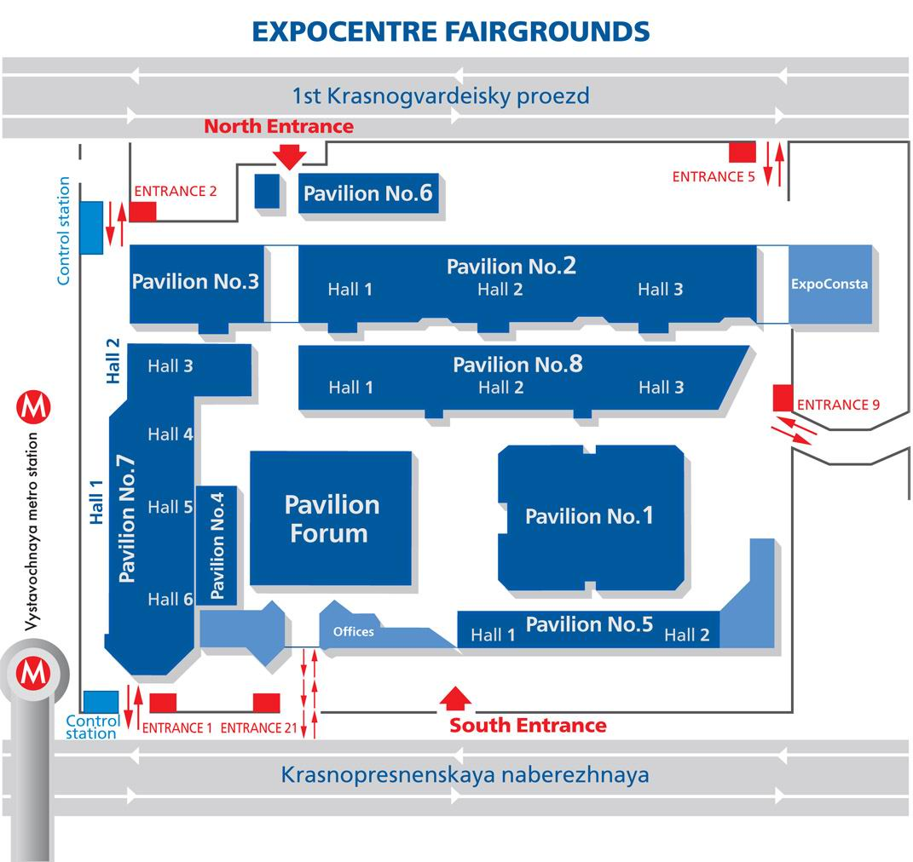

- Permanent personal passes can be issued in advance at the office of the organizers (of the Euroexpo Company) at the address: 35 Arbat Street, 4th floor, office 440. Tel.: +7 495 925 65 -61,-62.

Transport entry onto the Expocentre CJSC grounds

- A general power of attorney or a power of attorney to obtain a one-time pass for a vehicle driver-forwarder, or for a cargo attendant, shall be prepared, together with two copies of a check-in letter for the inbound/outbound carriage of exhibits. The check-in letter must be prepared on a corporate letterhead, or on a waybill, and must be affixed with the company seal and the signature of a senior executive.
In addition to the exhibits and equipment, house wares and household appliances that are being brought in must be listed.
- A pass shall be obtained from the attendant at the Front Control Station (FCS) by means of presenting him or her with the general power of attorney or the power of attorney for obtaining a one-time pass, as well as one copy of the check-in letter, and stating the license plate number of the vehicle that will be used for the inbound/outbound carriage of the equipment. The FCS attendant shall inform you of the admission time and the availability of free spaces in the loading area.
- At the checkpoint (CP) (indicated by the FCS attendant), a completed one-time pass for the vehicle and one copy of the check-in letter shall be presented to security, in addition to which the vehicle shall undergo a security inspection. The guards shall make a note of the check-in time.
- You shall proceed to the unloading point and shall present one copy of the check-in letter to the administrator of the pavilion in which your stand will be located. A guard shall indicate a parking space near the setup gates.
- If you are bringing in banners, upholstery fabric, or other combustible materials/exhibits, a representative of the firefighting service (FD / fire department / No. 160) must witness a letter of inbound/outbound carriage. Certificates of compliance for combustibility, smoke generation, and toxicity must be physically present.

During the exhibition, including the opening day, vehicle access for import and export of exhibits is allowed only in the morning from 8:00 to 9:30 and in the evening from 18:00 to 19:30.

IMPORTANT: One hour is allotted for unloading/loading, starting from the time indicated on the pass for the vehicle.

The use of motorized vehicles (including vehicles equipped with lifting devices) and personnel of other organizations on the exhibition area is prohibited. The official handling agent in Expocentre is JSC "ExpoWesTrans".

Electricity Supply and Water Connection

Power connection with capacity of 10 kW is included in the exhibitor’s standard package. If you require additional electricity supply, please fill in the Form 6C/6D and submit it to the technical department.

To order water utilities/connection to a drainage system please complete the form 6C/6D (additional equipment) and submit it to the technical department.

Euroexpo Vienna:  Mr. Kirill Gavrilin  Tel.: +43 1 230 85 35 39  Fax: +43 1 230 85 35 -50/-51  Email: k.gavrilin@euroexpo-vienna.com | Euroexpo Moscow:  Mr. Andrey Ivanov  Email: andrey6515@mail.ru

Delivery of Freight

Official forwarding agent provides a package of freight, forwarding, customs and broker's services at fairs, exhibitions and other events in Russia and abroad.

RUSSIA FACHSPEDITION Dr. Lassmann GmbH
Talpagasse 8, 1230 Vienna, Austria
Tel.: +43 (1) 865 01 01, Fax: +43 (1) 865 05 05
Contact: Mr. Georg Tomasu
Tel.: +43 (1) 865 01 01 40
e-mail: g.tomasu@russia.at
www.russia.at

ExpoWesTrans
Building 2, 14 Krasnopresnenskaya quay, Moscow, Russia, 123100
phone. : (495) 605-66-50, fax: (495) 605-34-31
http://www.expowestrans.ru/eng/index.php
e-mail: ewt@ewt.ru

Cargo handling services for foreign exhibitors may be ordered only by the exhibition’s official forwarder! The Organizers are not responsible for any problems/troubles (transportation and customs clearance of the exhibition goods) caused by contracting another forwarding agency.

Please DO NOT send any courier to the exhibition!

Fire Safety Regulations

Fire safety rules which have been established on the grounds of the exhibition complex.

1. The exhibition’s management renders the pavilions (the facilities) for holding exhibitions in a suitable condition and guarantees basic fire safety conditions taking into consideration construction standards and regulations.
2. Exhibition participants bear responsibility for fire safety and observance of fire prevention measures during assembly, operation and dismantling of fairs and exhibitions.
3. The exhibition’s management and local fire protection agencies exercise control over the execution of the present regulations.
4. Exhibition participants beforehand, but not later than a month before the beginning of assembly operations, are obligated to present to the EXPOCENTERE Closed Joint Stock Company (CJSC) fire unit information about all radioactive, combustible and highly explosive materials and exhibits for acceptance of appropriate agreed safety measures. The entry of the materials and exhibits indicated above without the permission of the EXPOCENTRE CJSC is not permitted.
5. Stationary booth structures may be assembled from conventional building materials (with the usual class of inflammability.) Fireproof and materials that are difficult to light must be used for decorating booth spaces, offices, podiums and enclosures. All combustible materials must be treated with a flame retardant. The use of drapery materials of combustible plastics which have not been treated with a flame retardant is not allowed. The use of combustible synthetic trim materials in evacuation routes (in the halls, vestibules, corridors and in stairwells) is forbidden. Documentation which characterizes the degree of material combustibility must be presented for all materials being used in booth construction.
In the construction of two-story, two-tiered exhibition booths and display booths which have increased danger of fire, the latter must be equipped with additional fire alarm sensors, which are connected to the exhibition complex’s fire alarm console (a paid service.)
Certificates of fire safety must be presented for all booth materials used in the organization of exhibits.
6. Carpets and carpet strips being used in the pavilions must be fastened solidly to the floor, around the perimeter and at the joints. They must be assembled from material that is difficult to ignite (will not catch fire from burning cigarettes or matches.)
7. Approaches to the pavilions (halls) must be free during assembly and dismantling of exhibits. Transportation boxes, packing and similar materials and equipment being used must be removed immediately from the pavilions.
8. It is prohibited to place thresholds and turnstiles in the passages for evacuation and movement of visitors. Aisles for visitors must be not less than 3 meters and ensure circular movement, and also free access to evacuation aisles, power panels, fire cabinets and other firefighting equipment. Stairwells, emergency exits, aisles, corridors and lobbies must be kept constantly free of any objects which interfere with the movement of people.
9. In the event fire cabinets or power panels are located in the area of an exhibition booth, free access to them must be ensured (the use of decorative curtains or other drapery which does not interfere with instantaneous access is allowed.) The use of a the special “ПК” symbol [PK – Fire Cock] must be used in similar masking of fire cabinets (it will be drawn on the curtain or drapery and must be distinguished easily from the aisle.)
10. It is forbidden to place displays from combustible materials or to locate offices and office furniture in stairwells or beneath flights of stairs.

Penalties will be levied against exhibition participants, including the representatives of foreign firms, in accordance with established procedure, for violation of fire safety regulations by agencies of the State Fire Inspectorate in accordance with Russian Federation laws.

Additional equipment for booths must be ordered and paid for not later than two weeks before the exhibition

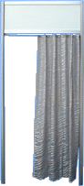  Curtain | 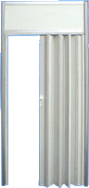  Sliding door | 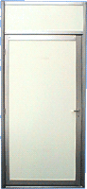  Swinging door
Wall panel with glass | 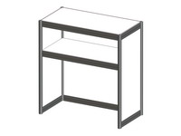  Info desk centre unit  1000х500х1100mm | 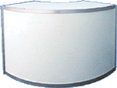  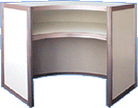  Info desk corner unit  R-1m
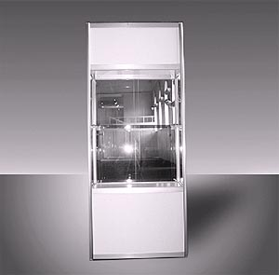  Showcase 1000х500х2500mm | 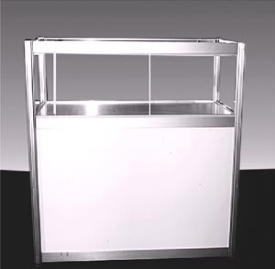  Showcase 1000х500х1100mm | 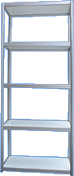  Built in 5-shellf unit  1000х500х2500

Additional equipment for booths must be ordered and paid for not later than two weeks before the exhibition.

 | 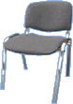  Conference chair | 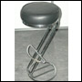  Bar stool
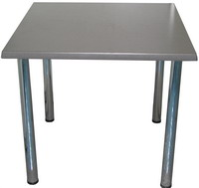  Table 700х700mm | 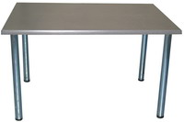  Table 700х1400mm | 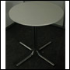  Table D 0,6; H-0,8
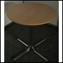  Table D 0,6; H-0,8  (table top bright beech) | 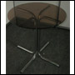  Table D 0,6; H-0,8  (glass table top) | 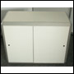  Cupboard; H-0,7
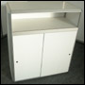  Cupboard; h-1,1 | 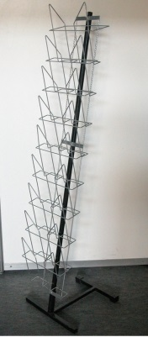  Z-form brochure holder | 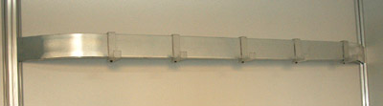  Coat rack (wall)

Additional equipment for booths must be ordered and paid for not later than two weeks before the exhibition.

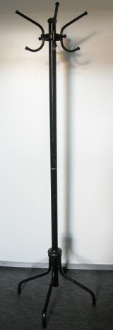  Coat rack (clothes tree) | 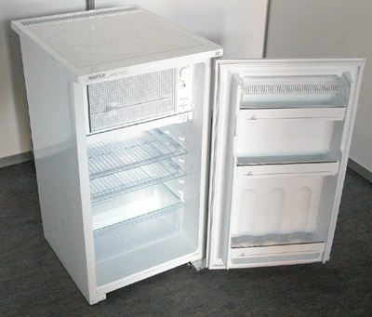  Refrigerator 120 L | 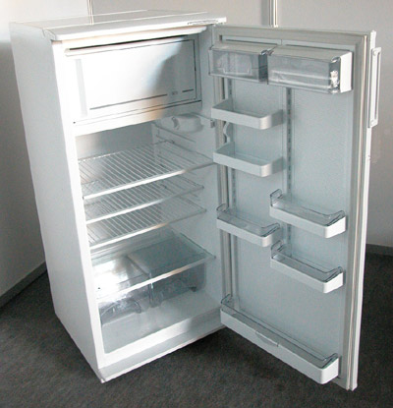  Refrigerator 240 L
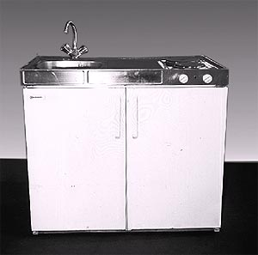  Kitchen unit with a refrigerator, burner and hot water | 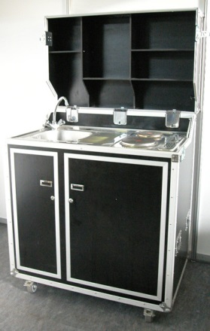  Kitchen unit „Kit Kase“  with a refrigerator, burner and hot water | 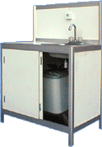  Kitchen sink with hot water
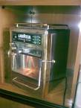  Coffee machine | 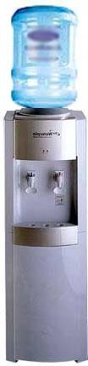  Water cooler | 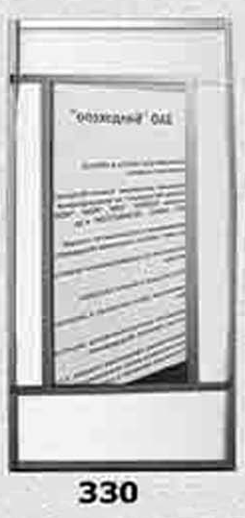  Mirror

Additional equipment for booths must be ordered and paid for not later than two weeks before the exhibition.

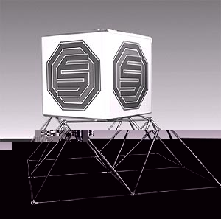  Cube with inside illumination | 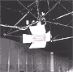  Halogen lamp  300W | 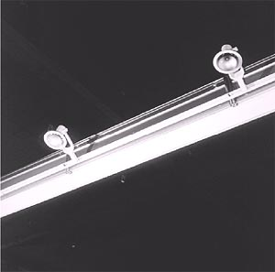  Spot on power supply track 100W
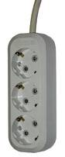  Power outlet 220V  (max. 1kW) | 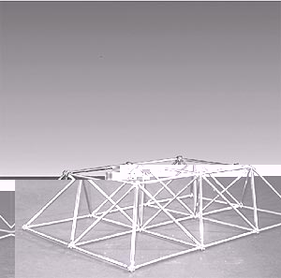  Solid construction | 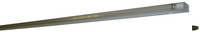  Fluorescent light 40W

CARPET SAMPLES for standard stands

Grey carpet is included in a stand rent. To order other colours please fill in form 6B

Grey | Green
Dark grey | Dark green
Light Blue | Red
Blue | Bordeau
Dark Blue | Black

Colour vinyl scale for the ORACAL 641 Scale
for walls and standard equipment

Please fill in FORM 5 to order colour vinyl for the walls and furniture

Number | Color Name | Color
000 | transparent
010 | white
020 | medium yellow
019 | signal yellow
021 | yellow
022 | light yellow
025 | brimstone yellow
026 | purple
312 | burgundy
030 | dark red
031 | red
032 | light red
047 | red orange
034 | orange
036 | light orange
035 | pastel orange
404 | royal purple
040 | violet
043 | lavender
042 | lilac
041 | pink
045 | soft pink
562 | deep sea blue
518 | steel blue
050 | dark blue
065 | cobalt blue
049 | king blue
086 | brilliant blue
067 | Blue
057 | traffic blue
051 | gentian blue
098 | gentian blue
052 | azure blue
084 | sky blue
053 | light blue
056 | ice blue
066 | turquoise blue
054 | turquoise
055 | mint
060 | dark green
613 | forest green
061 | green
068 | grass green
062 | light green
064 | yellow green
063 | lime tree green
070 | black
073 | dark grey
071 | grey
076 | telegrey
074 | middle grey
072 | light grey
080 | brown
083 | nut brown
081 | light brown
082 | beige
082 | cream
090 | silver grey
091 | gold
092 | copper

RAWN UP ON AN ORGANIZATION’S LETTERHEAD

Information about a structure for hanging inside a pavilion

Exhibition ___________________________________________________________________________

Firm’s Name _________________________________________________________________________
(exhibitor)
Firm’s Name _________________________________________________________________________
(builder)
Pavilion Number_____________ Hall Number _________________ Booth Number ________________

Design dimensions____________________________________________________________________
(length x width x height)
Materials ____________________________________________________________________________

____________________________________________________________________________________

Structure weight______________________________________________________________________

List and total weight of equipment being suspended in the structure (lighting equipment, advertising supports, decorative lining)_________________________________________________________________
_____________________________________________________________________________________________________________________________________________________________________________

Total weight of equipped structure __________________________

Estimated number of suspension points ______________________

Estimated load at each suspension point ______________________

Estimated suspension height from the floor (according to the upper point of the structure) ____________

Person responsible for design ________________________________________________________

Person responsible for assembly (Last name, first, middle, position)

________________________________________________________________________________________

Person responsible for assembly (cell phone)______________________________________________
The customer’s firm bears responsibility for assembly and reliability of the structure, and also for organization of the fastening points in the structure.
The customer’s firm bears responsibility for quality and service of its own hoists.
The suspension of additional equipment (lighting equipment, advertising supports, decorative lining) onto a suspended structure is PROHIBITED!

I am acquainted and concur with the order of the execution of the order for the hanging and removal of structures within the pavilion. A drawing of the design (executed on the organization’s letterhead) must be affixed to the letter, signed by the company manager and stamped.

Signature of manager AGREED TO:
of enterprise (placing order)

CHECK-IN/-OUT LETTER (sample)

Please print on your company’s business paper «____»______________20______

ЦВК «Экспоцентр»/ To the exhibition administration of “Expocentre”

От/ From_________________________________________________
(название организации / Company name)

Зал/ Hall__________ Стенд/ Stand_____________

Просим Вас разрешить ввоз-вывоз экспонатов на выставку/ We ask for permission to bring our exhibits to/from the exhibition
_________________________________________________________________________
проходящую на территории ЦВК «Экспоцентр»/ which will be held at the exhibition centre „Expocentre“ с/ from «_____»__________________20________ по/ until «_____»_________________20_______.

Список экспонатов:/ Exhibits:

1.___________________________________________кол-во/ Quantity________
2.___________________________________________кол-во/ Quantity________
3.___________________________________________кол-во/ Quantity________
4.___________________________________________кол-во/ Quantity________ 5.___________________________________________кол-во/ Quantity________
6.___________________________________________кол-во/ Quantity________
7.___________________________________________кол-во/ Quantity________

Печать Организации/ Company stamp Подпись/ Signature_______________________

