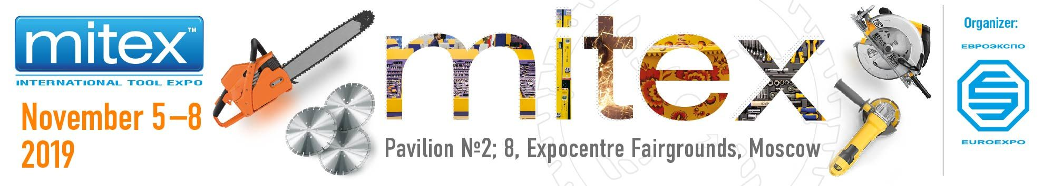

Dear Exhibitor,

Hereby we send our compliments to you and wish you fruitful and successful work at the coming exhibition.
Please find below the information which will help you entering the territory of CEC “Expocentre” for move-in and stand set-up.

Organizer’s Stand
The on-site Organizer’s Stand will be located in Pavilion 8, hall 3. The Organizer’s Stand will be working as follows:
4 November 2019, 8.00 - 20.00 (set-up and move-in)
5-7 November 2019, 09:00 - 18:00 (exhibition days)
8 November 2019, 09:00 - 16.00 (exhibition day), 16:00 - 20.00 (dismantling, move-out)

Exhibitor badges and invitation tickets

- You can also get your invitation tickets and exhibitor badges in advance at “Euroexpo” office (35, Arbat str., 4th Floor, office 440, from 11.00-18.00 on weekdays, lunch break: 13.00-14.00), after receiving an e-mail confirmation that they are ready.
- You can also get the badges on-site at the Organizer’s Stand in Pavilion 8, hall 3.

Access to the exhibition pavilions
To enter exhibition pavilions, the Exhibitor’s representative is to have:
- - an exhibitor badge (valid for the whole exhibition period, including set-up and dismantling),
or
- - Work and Service pass (valid for the set-up/dismantling period only),
or
- - one-time entry pass that can be obtained at the Access Control Departments located at the side of 1st Krasnogvardeysky Proyezd or at the side of Krasnopresnenskaya Naberezhnaya. The Exhibitor’s representative is to provide a completed Form D.02 and a passport.

Please have your identity document (passport or ID card).

Entry passes at set-up/dismantling
All Exhibitor employees including the staff involved in stand construction (except the drivers) are to have either a Work and Service pass or an Exhibitor badge.
If you need to provide your staff with extra entry passes for set-up period, you can get the free Work and Service passes at CEC “Expocentre” from 21 November 2019 or on the move-in day.
- Work and Service passes are valid for the set-up/dismantling period only.
- Stand-Building Contractors are to receive the Work and Service passes for their staff by themselves.

The Work and Service passes for set-up/dismantling can be obtained at CEC “Expocentre” by providing the following documents:

- An Application Letter for Work and Service Passes printed on the Company’s letterhead, duly stamped and signed by the Company’s CEO. The applications should also show the names and passport details of technicians, engineers, builders and other Exhibitor’s and Contractor’s staff involved in construction and dismantling of the exhibition stand (D.02 Form, 2 copies);
- The Power of Attorney (D.01 Form, 3 original copies, the sample is enclosed).

Getting Work and Service Passes:

- The Application for Work and Service Passes with staff listing is to be provided to the CEC “Expocentre” Management Building (pavilion 2, tower 2, entrance from the gallery between Pavilion 2 and Pavilion 8). There the Application Letter is to be marked with authorization note.
- After getting the authorization note, you can get your Work and Service Passes at “Expocentre” Service Department. To get to the entry passes, you should have a Power of Attorney (D.01 Form).

Contact persons in CEC “Expocentre":
Alexandra Kuznetsova, phone: +7 (495) 795-25-98
Valeriy Samusev +7 (499) 795-41-65

Working hours: 10:00-17:00 on weekdays, lunch break: 12:00-13:00

Please note that all entry passes should be fully completed. An identity document must be presented together with the pass, if required.

Move-in procedure

The move-in of exhibits is permitted on 4 November 2019 from 08.00-19.30.

The access of personal cars to the territory of CEC “Expocentre” is permitted on 4 November (move-in day) from 15:00-19:30.

The access of trucks to the territory of CEC “Expocentre” is permitted on 4 November (move-in day) from 08:00-19:30.

We enclose to this letter the Move-in/move-out letter sample (D.O3 Form) and Power of attorney sample (D.01 or D.01A Forms), that are to be printed on the Company’s letterhead, stamped and signed by the Company’s CEO and to be submitted during the move-in.

- To enter CEC “Expocentre” by car, the Exhibitor’s representative is to receive a free one-time entry vehicle pass at Pavilion 2 Management Office. The Exhibitor’s representative is to provide 3 copies of Move-in/ move-out letter (D.03 Form), the Power of Attorney (D.01 or D.01A Form), and the car registration plate number. The Power of Attorney samples and CEC “Expocentre” map are enclosed.

Pavilion 2 Management Office is located in pavilion 2, tower 2, entrance from the gallery between Pavilion 2 and Pavilion 8

- After obtaining one-time entry vehicle pass, the car is to enter CEC “Expocentre”. Please present the vehicle for a security inspection, and proceed to the loading/unloading site. The Security Officer is to make a note in the Move-in/ move-out letters.

- Vehicles should leave the territory of CEC “Expocentre” immediately after the exhibits and equipment are unloaded.

- The small exhibits, office equipment and appliances can be hand-carried against an inventory pass to be obtained at Pavilion 2 Management Office. Inventory passes are issued against the completed Move-in/ move-out letter (D.03 Form).

The cars are alowed to enter CEC “Expocentre” through the Gate 2 (1st Krasnogvardeysky Proyezd)

Procedure for obtaining admission permit to the areas with restricted traffic access

Please note that CEC “Expocentre” is located within Moscow’s Third Transport Ring of Moscow, which is the area with restricted freight traffic access. Therefore, you need to get an admission permit for cargo vehicles like TTK permit. The detailed information is on http://www.expocentr.ru/en/menu2/exhibitors/ttk/

For better transportation logistics CEC “Expocentre” arranges a free night parking (from 10:00 PM till 06:00AM) inside the venue for freight vehicles. To arrange parking for you vehicles, you need to provide a completed Move-in/ move-out letter (D.03 Form) and the Power of Attorney. The completed Move-in/ move-out letter (D.03 Form) is to be e-mailed to dispetcher@expocentr.ru in advance.

ATTENTION! Free night parking is arranged for freight vehicles only!

Additional move-in of exhibits
The exhibits/equipment can be additionally moved-in from 8:00-09:30 AM or from 18.00-19.30 during exhibition period (including the opening day). The single entry passes for additional move-in can be obtained at Pavilion 2 Management Office against the completed Move-in/ move-out letter and the Power of attorney.

Loading/unloading assistance
The trucks with load manipulator are not allowed to enter the territory of CEC “Expocentre”. You can order the transportation, loading and carrying services at “Expowestrans” company at CEC “Expocentre”, pavilion 2, tower 5. Phone: +7 (495) 605-03-27, 605-74-21, fax: +7 (495) 605-79-35, http://www.ewt.ru/, e-mail: exhib@ewt.ru. Services are to be paid according to “Expowestrans” rates.

Audio and Video Equipment
On the territory OF Expocentre Fairgrounds is prohibited:
* import and operate Wi-Fi routers, the penalty for unauthorized import is 23 600 rubles (excluding VAT).
* connect telecommunication equipment to the provided communication line to provide communication services to third organizations-violation entails disconnection of the line.
* to lay cable communication lines between the stands by the Exhibitor's forces and means;
* broadcast without permission or on an unauthorized frequency.

Please note
When planning the advertising activities and working exhibits demonstration at your stand, please note that according to the General Terms of Participation in Exhibitions”, the sound pressure level shall not exceed 75 dB on the boundaries of the indoor stands. The sound pressure level is controlled by metering equipment. The violation of this restriction is subject to penalty of 50 000 RUR.

Exhibits’ requirements:
If you deliver stand construction elements (well panels, carpet, decoration and construction elements), they are to be approved by ZAO Expoconsta and Fire Department No.160. For more information please contact:
ZAO Expoconsta: +7 (499) 795-39-03
Fire Department No.160:+7 (499) 259-13-12

We would like to remind you that all stand set-up works must be completed and the packaging material must be taken out of the exhibition pavilion on 5 November by 09:30 AM.

If the Exhibitor fails to observe these rules and to move-out the exhibits in time, the Expocentre reserves the right to dispatch the remaining exhibits to the warehouse of ExpoWesTrans, ZAO (1st Krasnogvardeisky proezd 14, tel.: +7 (495) 605-03-27, 605-74-21, fax: +7 (495) 605-79-35). The exhibits will be transferred to the warehouse and stored there at the Exhibitor’s expense. Transfer and warehousing of the exhibits will be charged according to ExpoWesTrans rates.

Storage for promotional materials and packaging shall not be arranged at exhibition stands. The violation of this restriction is subject to penalty by Fire Security Service.

Security
The security of the pavilion during set-up and dismantling is provided overnight from 20.00PM - 08.00AM.
Please note that the exhibitor holds a full responsibility for the safety of exhibits and other exhibition property from 08.00AM – 20.00PM.
Individual security for your stand in the morning from 8.00-10.00 or in the evening from 18.00-20.00 can be ordered prior to the Show at CEC “Expocentre”. Phone: (499) 795-39-92.

Stand cleaning
Stand cleaning shall be done by the exhibitor. A paid cleaning service is provided at the exhibitor’s request (Form 3).

Delivery of hot meals
Delivery of hot meals to your stand, catering services, receptions, cocktail parties, buffets.
Contact: Alexander, phone: +7 977 774 54 19 e-mail: as@euroexpoevent.ru

Business trip certificates
Business trip certificates can be endorsed at Pass Offices situated at the northern, southern and western entrances to Expocentre Fairgrounds (CEC “Expocentre” round stamp) or at the Organizer’s Stand (“Euroexpo” round stamp or “MITEX” stamp).

Access to the Exhibition and move-out procedure

Car passes for move-out can be obtained at Pavilion 2 Management Office by providing a copy of the authorized Move-in/move-out letter (Form D.03) and the Power of Attorney.

Move-out schedule:
8 November 2019, 16.00-20.00 - packing and move-out of small and precious exhibits (by personal cars)
8 November 2019, 18.00-20.00 - packing and move-out of exhibits by trucks
9 November 2019, 08.00-20.00 - dismantling

If the Exhibitor fails to observe these rules and to move-out the exhibits in time, the CEC “Expocentre” reserves the right to dispatch the remaining exhibits to the warehouse of ExpoWesTrans, ZAO (1st Krasnogvardeisky proezd 14, tel.: +7 (495) 605-03-27, 605-74-21). The exhibits will be transferred to the warehouse and stored there at the Exhibitor’s expense. Transfer and warehousing of the exhibits will be charged according to ExpoWesTrans rates.

Please do not leave your exhibits unattended during move-in, move-out and exhibition period!

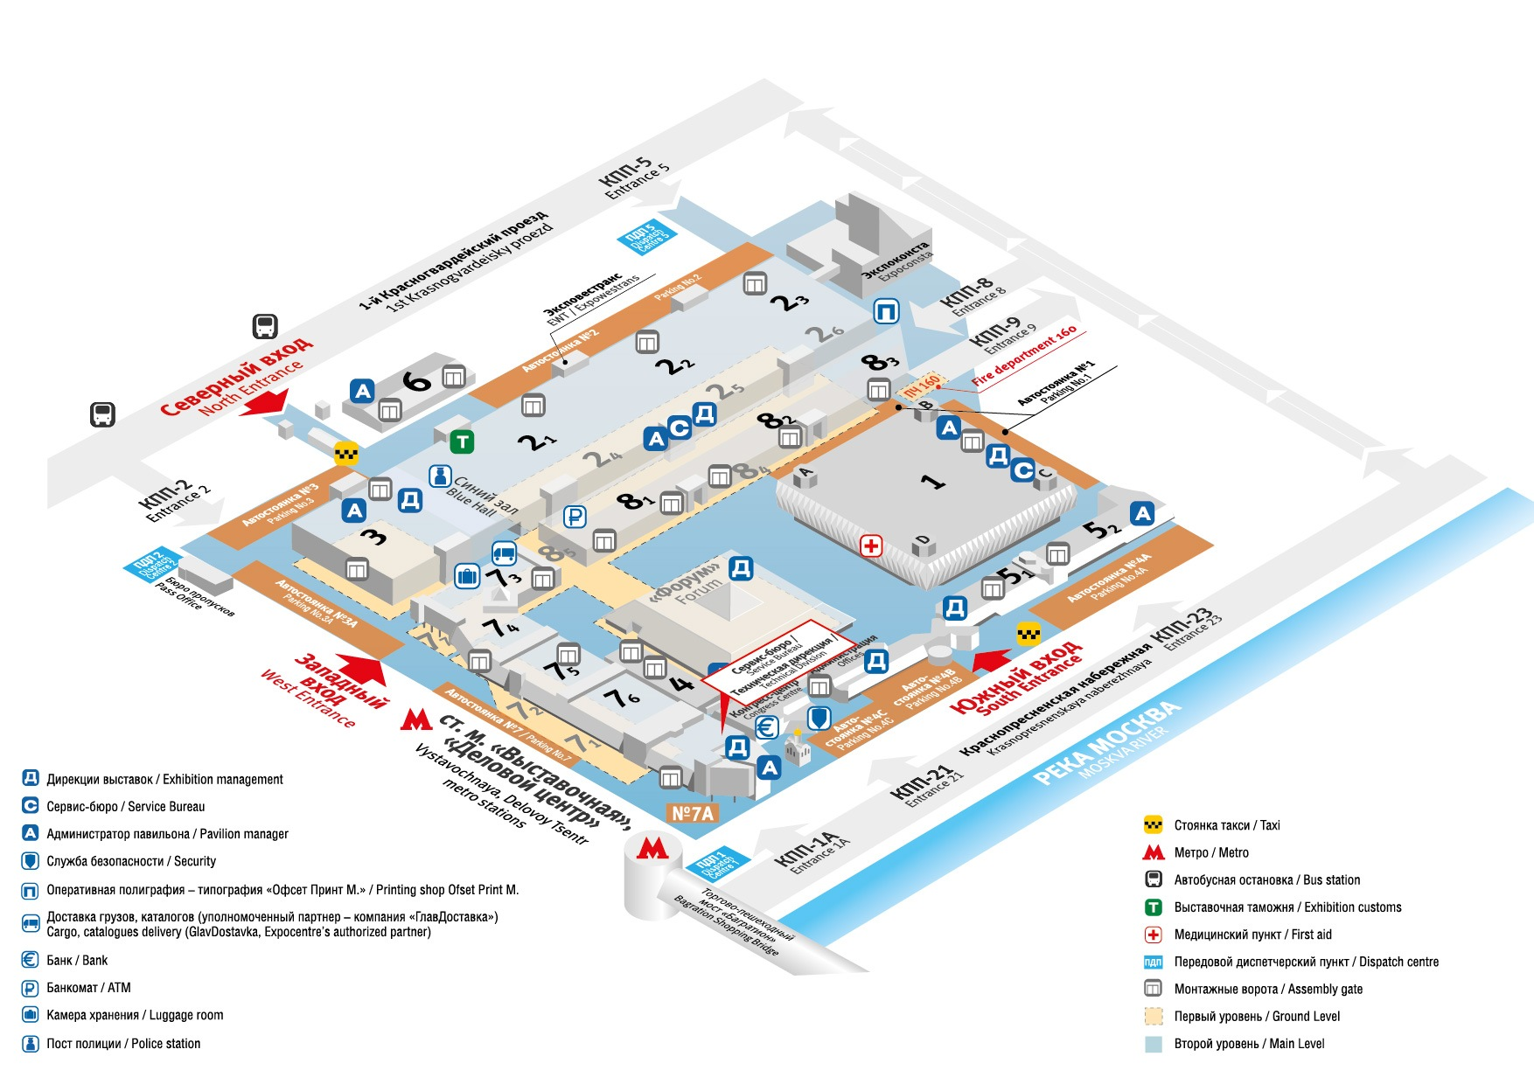
SAMPLE POWER OF ATTORNEY Document D.01

Company Letterhead

To be issued in 3 copies
Unnecessary paragraphs can be removed

Power of Attorney No.
Issue Date ___________
(dd-mm-yyyy)

Expiry Date ___________
(dd-mm-yyyy)

Company name and address________________________________________________

Hereby authorizes ______________________________________________________
(Full name, job title)
Passport # ______________________________________________________________

Issued by _________________________________________ Issue Date ____________

- to receive from “Expocentre” the listed below documents for participation at “MITEX-2019” exhibition:
- Vehicle Passes
- Work and Service Passes (valid throughout set-up and dismantling only)

- to sign other documents and perform other actions related to participation in the exhibition, including compliance with fire safety regulations, occupational safety and other regulations and requirements set by current legislation, receive and sign orders, proposals, protocols and statements of administrative offences and violations from state inspecting and oversight bodies*.

Signature of Recipient _______________________________________________________

Authorized Person _________________________ ____________________
(Full name) (Signature)

Chief Accountant __________________________ ____________________
(Full name) (Signature)

Company Stamp

* In accordance with the Russian Law No.69-FZ from 21 December 1994, in case of failure to designate a person in charge of compliance with fire safety regulations at an exhibition stand the said responsibility lies with the head of the participating company personally.

SAMPLE POWER OF ATTORNEY Document D.01A

For the delivery driver or a person accompanying the exhibits

Company Letterhead

To be issued in 3 copies

Power of Attorney No.

Issued date _________________________
(dd-mm-yyyy)

Expiry Date__________________________
(dd-mm-yyyy)
___________________________________________________________________________
(Company name and address)
___________________________________________________________________________
(Payer name and address)

Bank Account No.____________________________ in ________________________________
(Bank name)
hereby authorizes ___________________________________________________________
(Full name, job title)

Passport No.__________________________________________________________________

Issued by ___________________________________ Issued Date ___________________

to receive from ZAO “Expocentre” one-entry passes to move-in/move-out the exhibits for the “MITEX -2019” exhibition.

Signature of Recipient _______________________________________________________

Authorized Person _________________________ ____________________
(Full name) (Signature)
+
Chief Accountant __________________________ ____________________

Company Stamp

Sample Application Letter for Work and Service passes
(Contractor’s staff) Document D.02

to be submitted in 2 copies on your company’s letterhead

To the Organisers of “MITEX-2019” exhibition

Herewith we ask you to issue _____________ (quantity) Work Passes for our Contractor’s staff building the Stand of ____________________________________ Company participating in “MITEX-2019” exhibition, Pavilion No. __________, Hall _________, Stand No. ________.

Staff List
(with passport details and place of residence;
non-residents must present a copy of their Moscow registration papers

No. | Full Name | Passport details (date and place of birth, passport number, issue date, registration address)
1 | 2 | 3

CEO:

_____________________________ _______________________ Date: “___” _______________ 20____ .
Name Signature
Stamp

Expocentre Management: ________________________________________________________________
Signature Name Stamp

Sample Move-in/Move-out Letter Document D.03

Exhibition equipment, exhibits,
stand materials and structures
to be issued in 3 copies on your company’s letterhead
CEC “Expocentre”
To the Organisers of “MITEX-2019” exhibition
Copy: CEC “Expocentre” Dispatcher Service
(if you know the car registration number, please e-mail it in advance to: dispetcher@expocentr.ru)

Herewith we apply for the permission to move-in/ move-out the below listed exhibits and stand equipment to be demonstrated at “MITEX-2019” exhibition at Stand# _______, Pavilion #_______:

Company name __________________________________________  The equipment to be moved in/out on “___” ___________2019  Type of vehicle (capacity**) ___________/____________  Unloading conditions** ________________(upper, rear, side)  Number of required runs per day ____________  Vehicle state registration number __________ Trailer state registration number ____________  Name of driver ______________________________________________  Date of birth______ Place of birth ______________ Cell phone: ____________ | To be completed for each vehicle

# | Exhibits | # units
1.
2.
3.
…..

* Add lines if required
** For trucks only

We guarantee the timely removal of equipment, exhibits, packaging, bulk packages and stand construction materials.

Date: ________________ Signature _________________First and last name:______________________

Please note: If you deliver stand construction elements (well panels, carpet, decoration and construction elements), they are to be approved by ZAO Expoconsta and Fire Department No.160.

The delivery of LCD panels, plasma panels, powerful projectors, loudspeaker equipment and concert lighting equipment is to be approved by Service Bureau.

Stamp and signature  of ZAO Expoconsta | Stamp and signature  of Fire Department No. 160
N  Stamp of Service Bureau (for Exhibitors) | Stamp and signature of Exhibition Management (for Contracted Stand Builders)

